Checkout Flow
# Source: Chatgpt (GPT-5-Mini) at [1/21/2026]
The checkout flow is the front-end part of your payment system that guides the customer through submitting their payment information. In a custom bank integration, you build this flow yourself — meaning you control the design, behavior, and data handling.

🧩 Purpose of the Checkout Flow
# Source: Chatgpt (GPT-5-Mini) at [1/21/2026]
- Collect payment information (e.g., card number, expiration, CVV).
- Collect billing/shipping info if needed.
- Provide real-time validation of input.
- Allow users to confirm and submit their payment.
- Integrate with your back-end logic to send data to the bank's payment API.

🧱 Key Elements of a Checkout Flow
# Source: Chatgpt (GPT-5-Mini) at [1/21/2026]
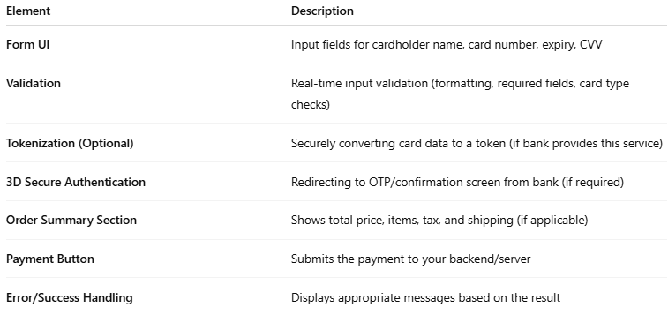

Element | Description
Form UI | Input fields for cardholder name, card number, expiry, CVV
Validation | Real-time input validation (formatting, required fields, card type checks)
Tokenization (Optional) | Securely converting card data to a token (if bank provides this service)
3D Secure Authentication | Redirecting to OTP/confirmation screen from bank (if required)
Order Summary Section | Shows total price, items, tax, and shipping (if applicable)
Payment Button | Submits the payment to your backend/server
Error/Success Handling | Displays appropriate messages based on the result

🛡️ Security Considerations (Very Important)
# Source: Chatgpt (GPT-5-Mini) at [1/21/2026]
- Use HTTPS only — always encrypt payment data in transit.
- Never store raw card data (unless you’re certified PCI-DSS Level 1).
- Sanitize and validate inputs to prevent injection or tampering.
- Use iframe-based or hosted fields if your bank provides them.

🔄 Typical Checkout Flow Steps
# Source: Chatgpt (GPT-5-Mini) at [1/21/2026]
- User fills in the payment form (card details, name, etc.)
- Form data is validated (e.g., Luhn check for card numbers)
- Data is sent securely to your backend
- Your server calls the bank’s API to initiate the payment
- Optional: Redirect to 3D Secure (OTP or biometric auth)
- Customer is redirected back or shown a status (Success / Failure)

🎨 Technologies Commonly Used
# Source: Chatgpt (GPT-5-Mini) at [1/21/2026]
- Frontend: HTML, CSS, JavaScript, React/Vue/Angular
- Validation Libraries: Card.js, Cleave.js, or custom
- Optional Tokenization: If your bank supports token APIs
- Backend: Node.js, PHP, Python, or any backend that talks to the bank's API

✅ Best Practices
# Source: Chatgpt (GPT-5-Mini) at [1/21/2026]
- Pre-fill or remember billing data (safely) for logged-in users.
- Disable the pay button after submission to prevent duplicate charges.
- Make it mobile-friendly.
- Show clear error messages from both validation and API responses.
- Log all actions securely for debugging and auditing.

📦 Example Use Case
# Source: Chatgpt (GPT-5-Mini) at [1/21/2026]
Let’s say you’re building your own payment system connected to a bank like CIB or QNB in Egypt. You'd create your own checkout page, collect the data, and pass it securely to the bank's API — no third-party providers like Stripe or PayPal involved.

